A Day in the Life of …

A Video Game Designer
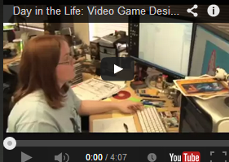
Watch the video and answer the questions below. When you finish, take a screen capture of this worksheet and paste it into your OneNote binder.

Kim is a video game designer for Mind Control Software. As part of ConnectEd's "Day in the Life" series, Kim discusses her duties as a level designer and the education that helped her land the job.

- What is the name of the game that Kim played with her boss at her last job?
- What does she mostly spend her day building?
- How does she typically start planning to create her game?
- What is the name of the first stage in the Editor?
- Why does she have to play the game after every step she makes?
- What was her previously intended profession?
- Which college did she attend to study gaming?
- What percentage of graduates from this college is hired into the video gaming industry?

