What Does a Video Game Designer Do?

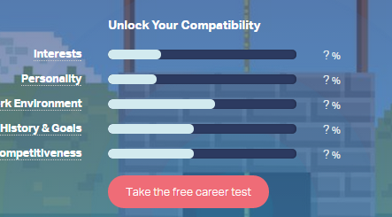
Find Your Compatibility
Go to this site, and click on Take the Free Career Test to see if you’re what it takes to be a Video Game Designer. You’ll need to sign up for an account. Take a screen capture of your results and paste them below:

2) What Does a Video Game Designer Do?
Still on this site, read the information on this page and answer the questions below: (just click in the gray box and start typing)
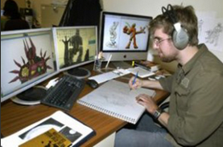
- What do most designers spend at least some of their time working as?
- What does a Lead Designer do?
- What is the phrase to describe games that are designed to make a profit?

3) Jobs
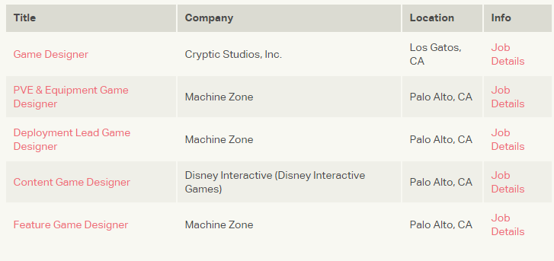
In the Jobs section , choose one of the companies and describe below what appeals to you most about the job title:

